

**Newsletter No. 1, Term 3, 2019**

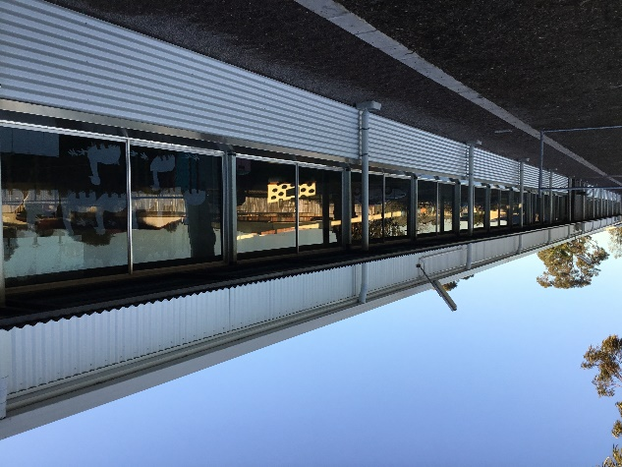**Dear Parents**

Welcome back for Term 3 and another exciting and busy Term of teaching and learning at Castletown PS.

**Building Update**: Significant works were completed over the holidays and importantly all students are safely back in their classrooms. We are now expecting the long veranda running down the front of Rooms 1-8 to be replaced and made higher and the serious drainage issues from the hardcourt area to be re-engineered and made good.

**BCA**: The 2018 Building Condition Assessment Report (BCA) was incredibly flawed. This was acknowledged by the Department of Education and they had it done again last Thursday. We eagerly await the release of the latest BCA because it will frame the maintenance/repair issues we still have and importantly, the realistic expected costings will be attached.

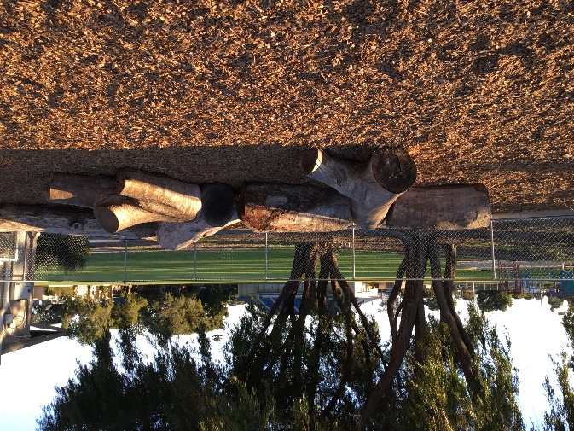**EC1**: This very old Pre Primary classroom was removed from the school on Saturday and we have commenced the development of a nature play area in the space provided. It looks great and the kids are really enjoying it.

**Planet Ark**: How wonderful it was to have Planet Ark here last Friday to support the Year 1 students from Room 1 to plant a large range of native plants in our school garden. Congratulations to Ms Holthouse for organising this event.

**P&C**: Last Friday the P&C hosted a ‘Meet & Greet’ at the Taylor Street Tearooms. It was very well attended and a lovely and friendly atmosphere made for a very pleasant evening.

**Parent Meetings**: Thank you to staff and parents who engaged in meetings here at school last Wednesday. The percentage family attendance across all Year levels at the school was high and feedback to me from a wide range of parents and teachers was that the meetings were positive, helpful and further developed good relationships in our school community. All teachers have extensive assessments to base quality judgements on student achievement and progress and along with Semester 1 Reports the Parent-Teacher interviews gave the opportunity for parents to discuss ‘the extent to how well their child is progressing is good enough.’

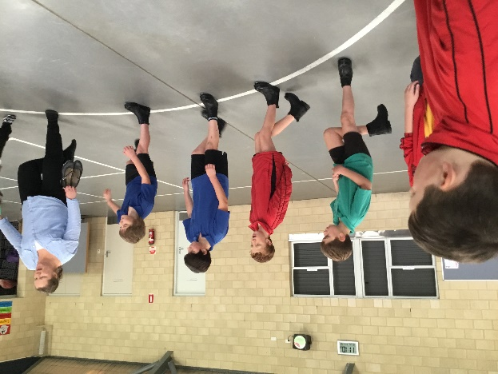**Tap Dogs**: Parent, and excellent Dance teacher Fiona Ryan, along with our very talented Chaplain Jake Meadley, are fine tuning our Year 5 Boys Tap Dogs Team. They are making outstanding progress and on the 18 September will be performing at an “Excellence in Public Education” showcase breakfast event at the Yacht Club. Well done Team. We are all very proud of you.

Colin Brand

Principal

**Deputy’s Desk – Student Services**

**Attendance**

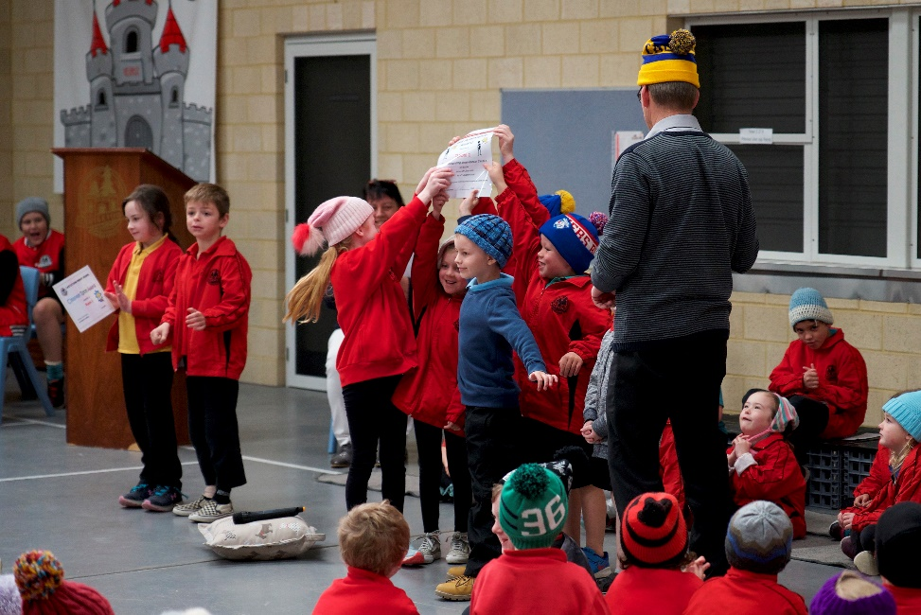Room 1 are to be congratulated for the fantastic effort in receiving the Attendance Award at the assembly last Friday. They had an attendance rate of **95.17%** for this term. As you are all aware our target rate for 2019 is ….. 95%. Well done for exceeding this rate.

Thank you to parents and carers for continuing to provide teachers with an explanation for your child’s absence.

If you are planning on taking your child or children on vacation during the school term would you please notify the School (email is preferable) so that an appropriate entry can be noted on School records.

Room 1 students were very excited to receive the Attendance Award at their Assembly.

**PEAC**

Our Year 4 students will be sitting a Primary Extension and Challenge assessment this Thursday.

The PEAC Program provides part time extension and enrichment for exceptionally able students in Years 5 and 6. PEAC offers a range of courses that provide identified students with work that is intellectually challenging. All students in Year 4 will have the opportunity to be assessed for suitability for the PEAC Program.

If you do not wish your child to be included in the PEAC assessment, please notify the school in writing by ***Wednesday 7th August.***

Laurie Palmer

Deputy Principal – Student Services

**Deputy’s Desk - Curriculum**

Welcome back to Term 3.

**K-7 Maths Summative Test**

In week 1 of this term, all students from PP-6 completed the K-7 Maths Summative Test. This Test provided valuable information to teachers about what concepts students have learnt well, what concepts require consolidation and what concepts will become the focus for Terms 3 and 4 for the remainder of the year. The teachers have used these results to determine focus groups in the classroom for term 3.

**Swimming Lessons Year 2-3**

Interm swimming will begin for Year 2-3 students in Rooms 4, 5, 6, 7, 8 and 13 on **Monday 12th August** and conclude on **Friday 23rd August**.   A pair of goggles (with name on) is strongly advised as they will alleviate sore eyes from the chlorine and a pair of thongs or sandals in your child’s bag will make it easier for changing at the pool.  Shoes will then be put on once back at school. Please ensure all student clothing, towels and bags are labelled with your child’s name.

The swimming lesson times are:

|  |  |  |
| --- | --- | --- |
| **BUS TIME (from school)** | **LESSON TIME** | **CLASSROOM** |
| 11.40 | 12.00 – 12.40 | Rooms 4 and 8 |
| 12.30 | 12.50 – 1.30 | Rooms 7 and 6 |
| 1.20 | 1.40 – 2.20 | Rooms 5 and 13 |

Parents are able to watch the lessons but will need to pay the $1 spectator fee to the pool.

**ESHS Science Fair**

Our Year 6 Students have been invited to attend the Science Fair at the Esperance Senior High School Junior Campus as part of Science Week next week. Students will view projects created by the Year 7 students and complete a questionnaire about the projects as part of the excursion. A reminder to all parents that permission forms and bus money are due back on **Wednesday, 7th August.**

**ESHS Enrolments**

A reminder to our Year 6 parents that you need to complete the Esperance Senior High School enrolment forms for your Year 6 child moving to Year 7 in 2020. These enrolment forms are important for the High School to facilitate their planning and organisation for 2020. If you require a new form you can collect a new one from the Esperance Senior High School office. These forms were due back to the high school at the end of Term 2.

Julie Fetherston

Deputy Principal – Curriculum

**School Photos Information**

Our School Photos will be taken on: Monday 26th of August, Tuesday 27th August and Friday, 30th August (Kindy Group B only). Every student will have their photo taken, whether they are purchasing photos or not.

The school has chosen to use the online ordering system. Your child was given an online ordering instruction slip and a unique student shootkey last term. Log onto [www.msp.com.au](http://www.msp.com.au) and follow the prompts to place your order.

If you lose your shootkey the school office will have a copy to quote back to you. The expiry date for online ordering is the 02.09.2019. Any orders received after this date will incur a $30.00 archive fee. You can email your order request through to [reorders.perth@msp.com.au](mailto:reorders.perth@msp.com.au) or call their office on 08 9240 8000.

**Family Photos:** Envelopes can be obtained from Administration. Family photos are taken each morning before school. Please ensure that your family envelope and payment are handed to the Photographers on photo day. If you do not have the correct money MSP will provide any change needed when photos are delivered to school. Family photos cannot be ordered online.

**Special/Sports Group Photos:** If your child is in a Special/Sports photo (eg Student Leader, Faction Captain, Year 6 Graduation) you will receive a link and password to the online gallery after photo day. You can then view and order if required. Photos will be delivered with the school’s bulk order.

Please Note: Class Groups, Individuals and Family Photos are not available to view online

**Kindy/PP POL News**

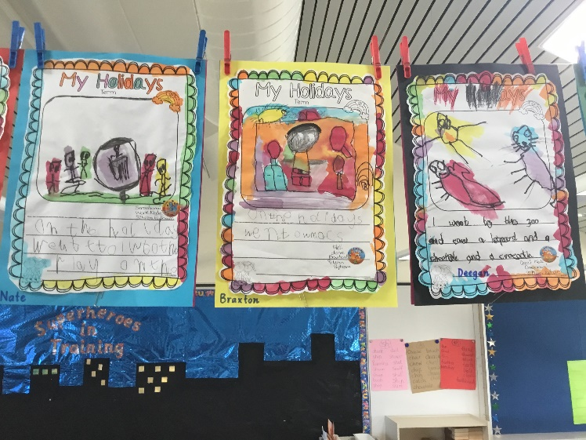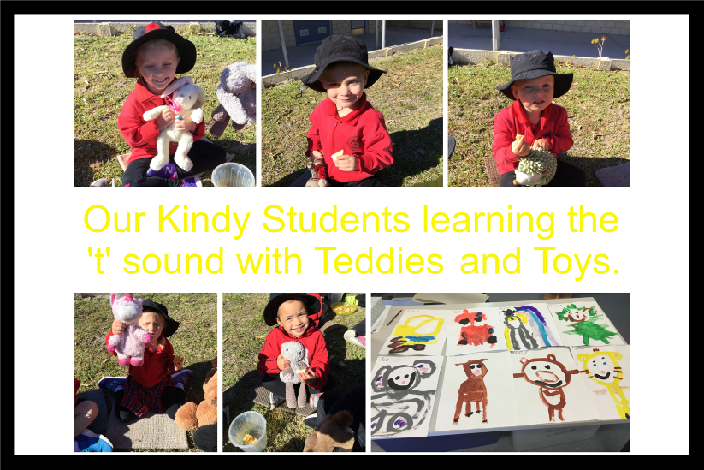The children have returned to school refreshed from their holidays and eager to learn. The first week was spent assessing English, including a Brightpath holiday recount assessment, and Mathematics to ascertain the children’s needs and to inform our teaching focus for Term 3. Pre-Primary classes are focusing on learning to spell whilst the Kindy focus is on beginning to learn letter sounds.

EC1 was removed over the weekend and replaced with the beginnings of a nature playground. We are hoping to add other elements to this area. The children are having a wonderful time playing on the logs, which helps to develop their coordination and balance skills. Thank you Mr Brand for all the negotiations behind the scenes to provide us with this exciting development to our play area.

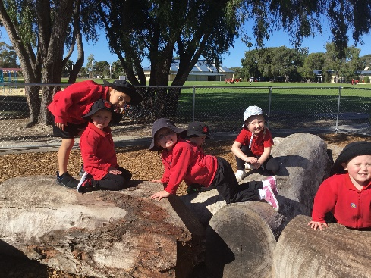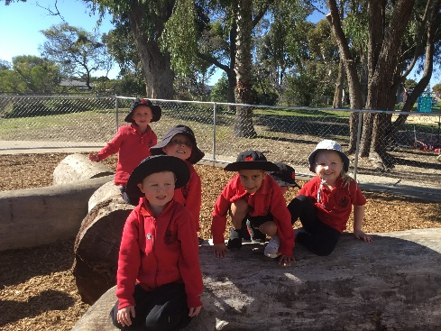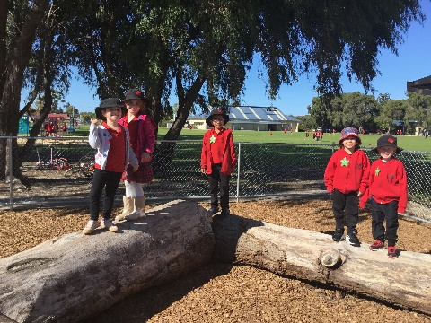

Jemma Gallop

Pre-Primary Teacher

**Years 1/2 POL News**

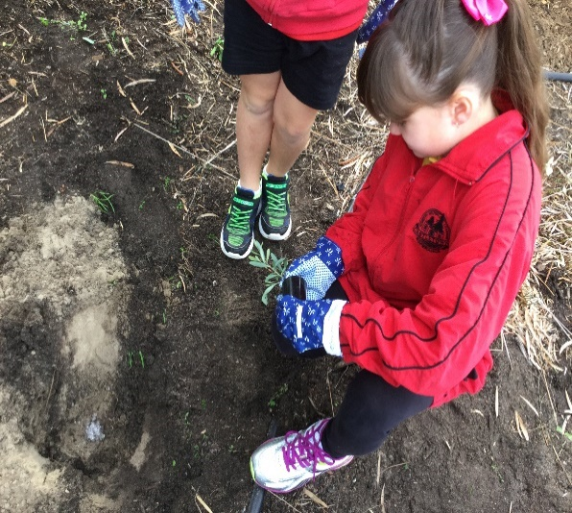**Room 1**

Friday 26th July was National Tree day.

Thank you to our parent Mrs Goldsmith for including Room 1 in planting a tree at CPS. Mrs Goldsmith and Mrs Ford showed the children special ways to plant and look after our grounds.

We all had to have our shoes scrubbed to start and finish the day. This was to not transfer any foreign material or germs into our new planting area.

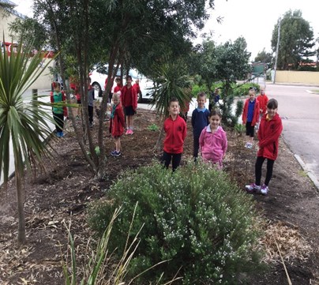We split into two groups (1 to plant into a pot and the other to plant into the garden).

The students enjoyed the experience and some even supported the town’s National Tree Day and planted more seedlings on Sunday.

A big thank you to Mr Bocka for digging our planting holes and helping during the morning.

**Math**

For Maths the children have been learning and exploring all about Australian coins. They have discovered a common link between our Australian animals’ theme and the features of Australian coins.

**Science**

Our main topic this term is all about materials and how they can be changed. The teachers have lots of exciting experiments and investigations planned for the term.

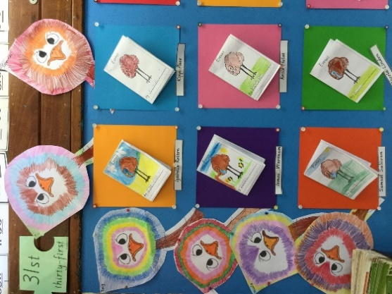**Brightpath**

Information Report Writing

All Year 1’s started a new writing genre this term – Information Reports. Our report writing theme is Australian animals. This week we learnt all about Emus. The students are very excited that we are learning all about Koalas next week.

Michelle Holthouse

Year 1 Teacher

**Years 3/4 POL News**

The Year 3 and 4 students have had a great start back to Term 3. Mrs Callow’s and Miss Morrissey’s students have settled into their new classrooms.

The Year 4 students have been having lots of fun learning about Drama and are working on building their self-confidence to perform in front of their peers. They have been learning the basics to drama like how movement, facial expressions and gestures can help accurately portray their character to their audience.

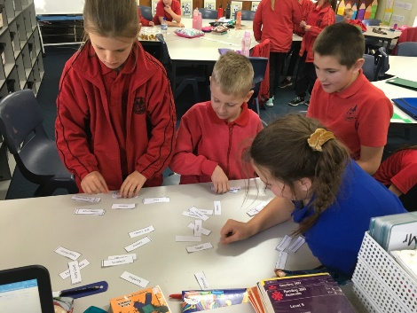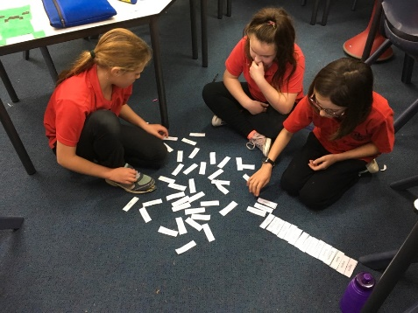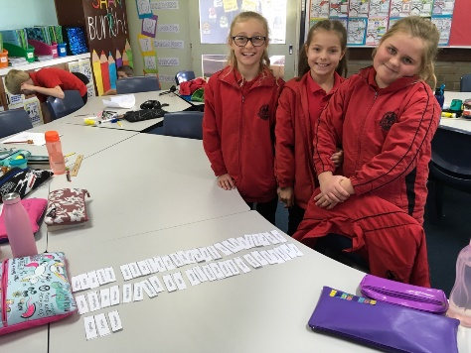The Year 4 students have also started learning about Geography and have been looking particularly at Europe and Africa. Here are some pictures of them having to sort through all of the 54 countries in Africa and put them in alphabetical order. It proved to be quite the challenge.

The Year 3 and 4 students have started learning about Information Report writing and are enjoying the research stage and learning about their chosen topic. The Year 3’s have also started learning about Geography and are learning more about Australia and locating the state, territories and capital cities.

Madison Wickstein

Year 4 Teacher

**Year 5/6 POL News**

Year 5/6 classes are prepping for a busy term ahead with Year 6 winter sports last Friday, Student Leaders meeting at Nulsen Primary School, class photos, Numero competition, Year 6 camp in Albany and the Year 5 ‘Tap Dogs’ performing at the Celebrating Excellence in Public Schools and choir and instrumental musical students preparing for the annual community Music Festival.

Across the two year groups this term, students will be learning about information texts in English, which makes great links to Geography and Chemical Science units. Drama is also being assessed and reported on this Semester and will be a great addition to our weekly timetables. A particular focus for Year 5/6 classes this term is the concept, ‘*Healthy Bodies, Healthy Minds’*. This topic promotes and encourages healthy eating, doing enough physical activity, being hygienic, practising mindfulness and building resilience, perseverance and a calm mind.

Importantly, parents were able to meet with respective teachers last week to discuss students’ progress in all Learning Areas and where to next. Thank you to the many supportive parents who booked in and met their child’s teacher. There was a very positive response from parents and from the teachers’ point of view, a valuable aid of communication between school and home.

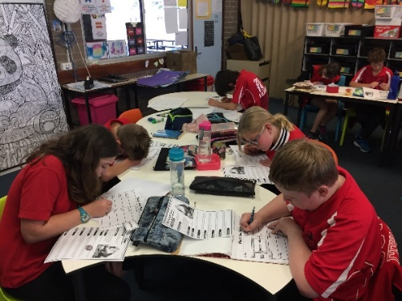In Week 4’s Senior Assembly, Room 10 will be hosting and presenting their class item- stay tuned!

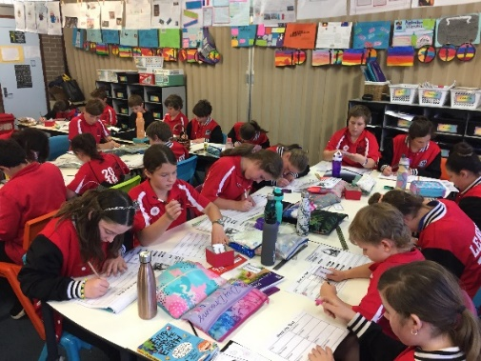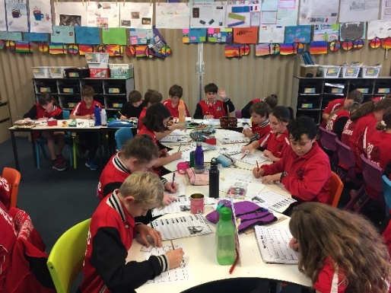

Nicola Rose

Year 6 Teacher

**Specialist POL News - Numeracy News**

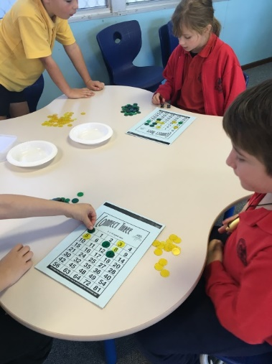

What a busy mathematical start we have had to the new term with students now attending Numeracy classes in Room 22, as a dedicated room for Numeracy.

Students in Kindy, Pre-Primary and Year 1 have been focussing on strategies for counting and for adding and subtracting small numbers.

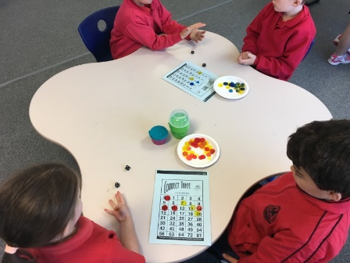These include: - Subitising, Counting on and back, Think BIG - count small, Build to 10 (Friends of 10), Bridge to the nearest 10, Doubles, Near doubles and Halves. Students are enjoying the hands on approach with card and boards games.

[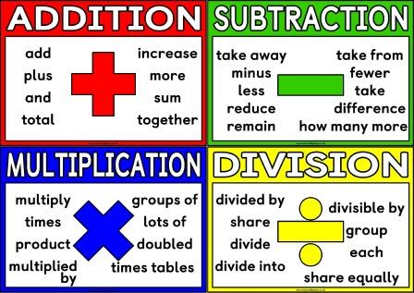](https://www.google.com.au/url?sa=i&rct=j&q=&esrc=s&source=images&cd=&cad=rja&uact=8&ved=2ahUKEwjKlLiuxODjAhU77XMBHc3NAVMQjRx6BAgBEAQ&url=https://www.instantdisplay.co.uk/number.html&psig=AOvVaw1ZrOQ29bM4-0MSGXqmlvcf&ust=1564709629862055)

Students in Year 2 and 3 have been focussing on their fluency in the operations of addition and subtraction and developing their knowledge of multiplication and division. We have discussed all the different words for the operations. Using dice to generate numbers, students are using the operations to connect 3 numbers on a game board.

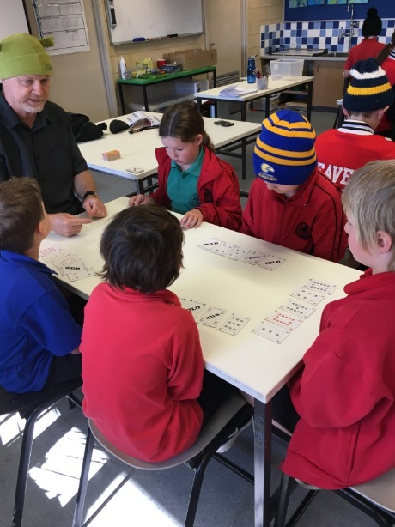Students in Years 4 – 6 have been working hard on their Numero skills. A group of students have been identified to participate in an additional Numero support program to prepare them to be selected and then to compete in the Esperance heat of the State Interschool Numero Competition. This event will take place on 9th September at the Civic Centre.

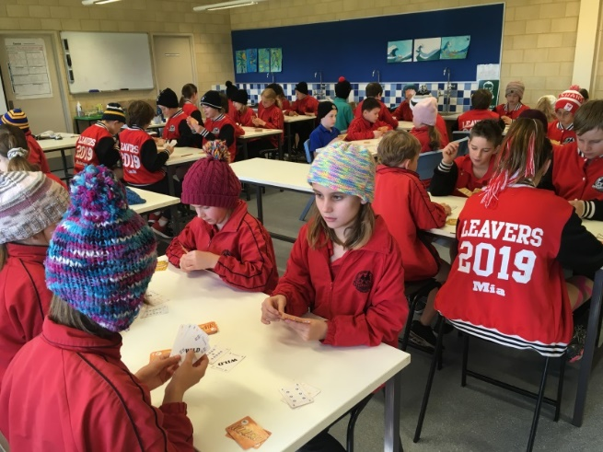

Ashley Weckert

Numeracy Specialist

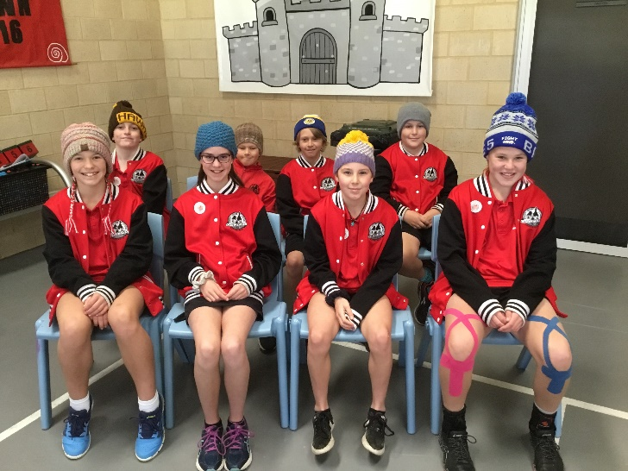**Student Leader’s News**

On Friday 2nd August, our Student Leaders encouraged all staff and students to participate in a “Beanies for Brain Cancer Research.” Students and Staff were able to wear their beanies to school for a gold coin donation. This fundraising raised $589! Well done Student Leaders on supporting such a worthy cause.

**Assembly hosted by Room 1**

Our wonderful Room 1 Year 1 students presented last Friday’s assembly with confidence and poise. They presented Mem Fox’s “I’m Australian Too” which is a story that highlights the diversity of our nation and celebrates our multi-cultural heritage. Their public speaking skills demonstrated the practice and perseverance they had undertaken in preparation for their assembly. Well done Room 1.

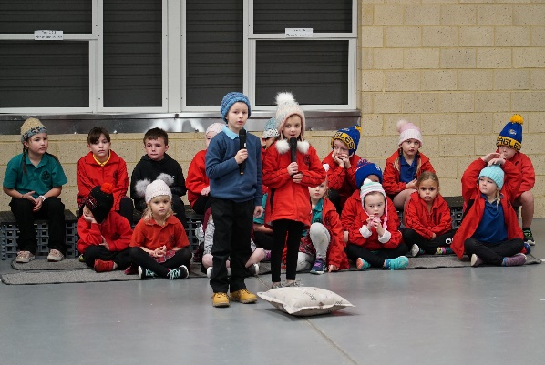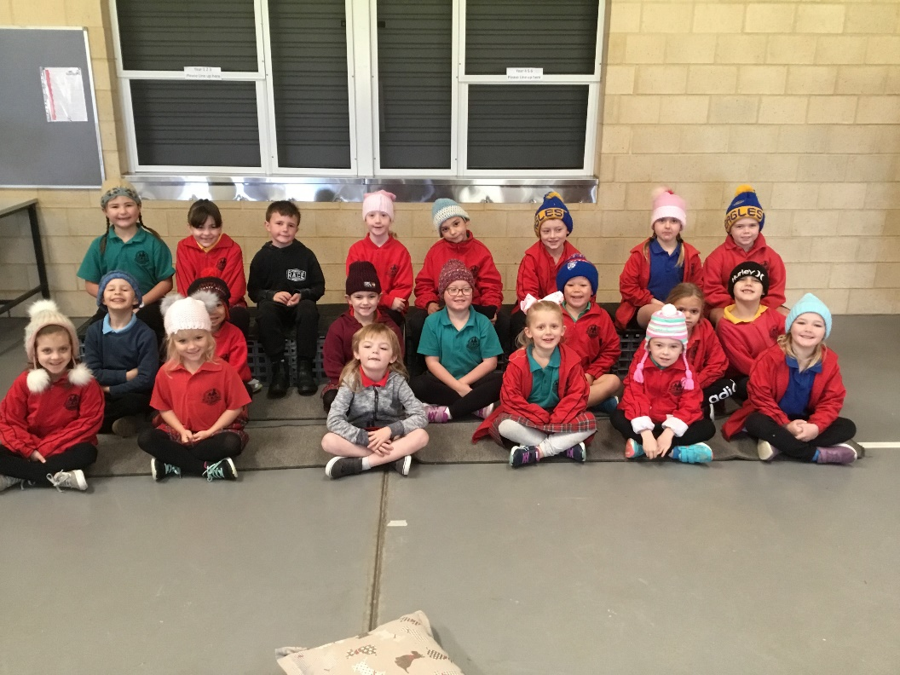

To view a gallery of photos from the assembly [click here](https://www.castletownprimaryschool.wa.edu.au/page/311)

Certificates of Merit

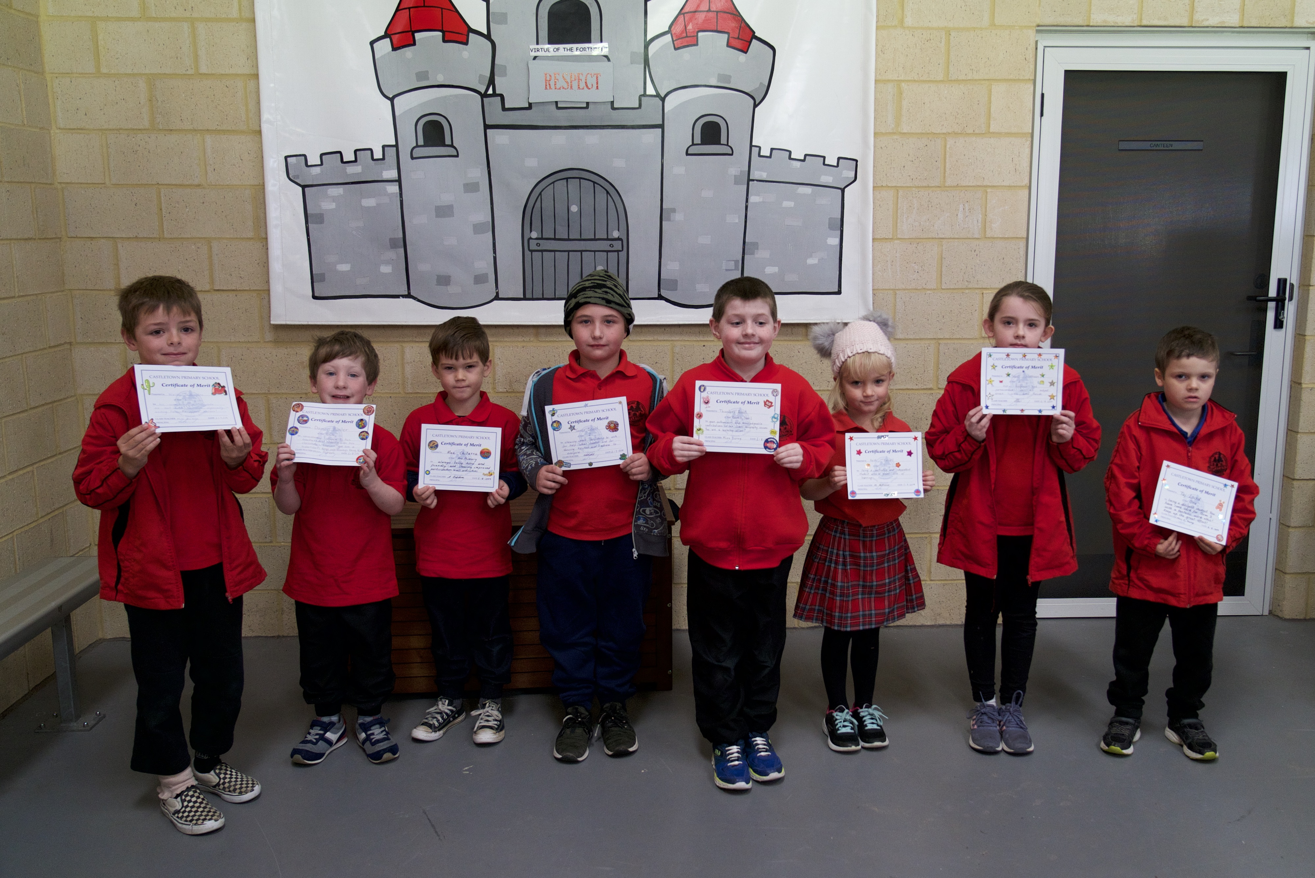

Congratulations to these students for

receiving a certificate of merit at Friday’s

Junior Assembly.

|  |  |
| --- | --- |
| Year/Room | Student |
| PP EC2 | Max Chitarra |
| PP EC3 | Lilah Adams |
| PP EC6 | Damon Hunter |
| Yr 1 Rm 1 | Heidi Hurrell |
| Yr 1 Rm 2 | Walter Shillington |
| Yr 1 Rm 3 | Taj Laird |
| Yr 2 Rm 4 | Theodore Roost |
| Yr 2 Rm 5 | James Boast |
| Yr 2 Rm 6 | Taliah Matthews |

Virtues Winners

Congratulations to these students for winning the Virtues Raffle at Friday’s Assembly for displaying virtuous behaviour.

|  |  |  |  |
| --- | --- | --- | --- |
| **Year** | **Room** | **Student** | **Virtue** |
| PP | EC3 | Annabelle | Helpfulness |
| 1 | 1 | Rosie | Perseverance |
| 2 | 4 | Martina | Respect |

RIBIT Readers

Congratulations to these wonderful RIBIT Readers.

|  |  |  |
| --- | --- | --- |
| **Room** | **Year** | **Students** |
| 1 | 1 | **100 nights** - Spencer Bower, Leah Robbins |
| 2 | 1 | **80 nights** – Jaxon Unwin  **100 + 120 nights** - Mikayla Stephen |
| 3 | 1 | **100 nights** - Abigail Pearson-Harper, Miley Lear, Xavier Bailey, Kate Ashman |
| 4 | 2 | **80 nights** – Theodore Roost |
| 5 | 2 | **120 nights** - Sophia Rickerby |
| 10 | 5 | **100 nights** - Kupa Henning, Mason Cowcher, Aaron Prossor |
| 14 | 4 | **100 nights** - Tahlia Maloney, Alice Navarre, Ava Neill, Ashlee Smith |

**Dates to Remember**

|  |  |
| --- | --- |
| 12th – 23rd August | Year 2/3 Swimming Lessons |
| 16th August | ESHS Science Fair – Year 6 |
| 20th August | Father’s Day Stall |
| 21st August | Student Leaders to Nulsen |
| 22nd August | Music Festival |
| 26th, 27th and 30th August | School Photos |

To view Community Events, [click here](https://www.castletownprimaryschool.wa.edu.au/page/217)